FOR IMMEDIATE RELEASE  CONTACT:  Abby Mathieu Swalga  abby@blenderadv.com  304-281-8097 (cell)  412-709-6149 | 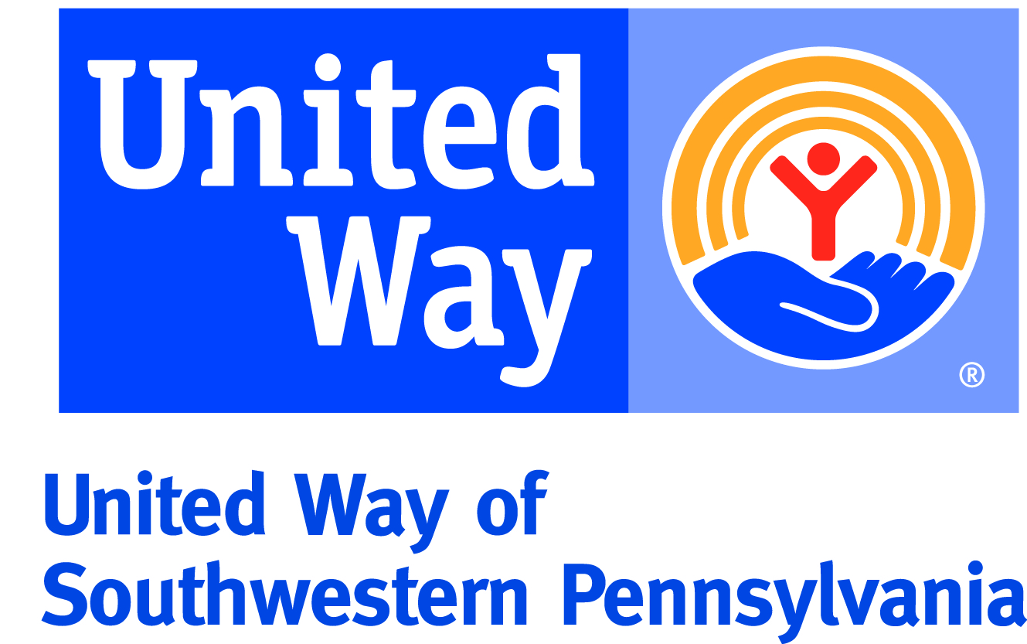
United Way’s Free Tax Prep program to help local working families
IRS will continue with refunds despite government shutdown

Pittsburgh, Pa. (Jan. 24, 2019) – In its tenth year, United Way of Southwestern PA will offer free, in-person tax preparation at 30 sites across the region to eligible working individuals and families. Appointments can be made now; sites opened the week of January 21, 2019. Services are available to low-income individuals and eligible furloughed government employees, and the IRS has reported they will continue to push refunds through.

“With the ongoing government shutdown, our free tax sites are available to qualified furloughed employees. For people who are struggling, these refunds address critical issues every year. Because of the government shutdown, we know there might be even more families relying on tax refunds to help meet their family’s basic needs and afford housing, utilities, food, transportation and more,” said Kiandra Foster, director of programs, United for Families, United Way. “While our focus is helping working individuals prepare their taxes and find well-deserved refunds, our Free Tax Prep program often serves as a way in for people to find access to other resources that might help them meet their family’s needs.”

This year, 470 volunteers have signed up to help individuals across the region file their taxes, help work through any challenges, and assist in getting the various tax credits they have earned throughout the year. During the 2018 tax season, hundreds of IRS-certified volunteers dedicated more than 22,000 hours to help prepare over 10,400 tax returns, helping taxpayers save over $1 million in paid preparation fees while returning over $15 million in tax refunds.

Many families who use United Way’s Free Tax Prep service are eligible for the Earned Income Tax Credit (EITC), one of the nation’s largest anti-poverty programs. Taxpayers who qualify and claim the credit could pay less federal tax, pay no tax, or even get a refund of $500 to over $6,400. This year’s 13th Annual EITC Awareness Day will be held on Friday, January 26, 2019, to help ensure millions of workers secure the tax credit they earned.

“As the government shutdown continues, we encourage all families who are impacted – whether through furloughed employment or lack of access to a government program – to call 2-1-1 or text 898-211,” said Angela Reynolds, senior director, United Way’s United for Families and 2-1-1. “We are here to help connect people in need with available resources to make sure people throughout our region are finding the help they need to get through this difficult time.”

Appointments for free tax preparation can be made now by dialing 2-1-1, texting 898-211, or visiting http://bit.ly/FreeTaxPrep19. Households with a total annual income up to $55,000 may qualify for free in-person tax preparation; free online tax assistance is available for individuals and families with a total annual income up to $66,000.

About United Way of Southwestern PA – United Way of Southwestern Pennsylvania, serving Allegheny, Butler, Westmoreland, Fayette and Southern Armstrong counties, leads and mobilizes the caring power of individuals, the business community and organizations to help local people in need measurably improve their lives. United Way creates long-lasting change for the betterment of our community.

###

